Parish Diary

Mon 10th Advent Feria
We pray for Farleigh Hospice

Tue 11th Advent Feria
We pray for Pastoral Visitors and Carers

08.30 Morning Prayer
09.00 Mums’ Mass
17.30 Vespers

Wed 12th Advent Feria
We pray for our Churchwardens

08.30 Morning Prayer
09.00 CTB United Prayers
(at Living Water Christian Centre)
19.00 Vespers
19.30 Mass

Thur 13th St Lucy (Virgin & Martyr)
We pray for the Royal National Lifeboat Institute

08.30 Morning Prayer
12.15 Mass
17.30 Vespers
19.30 RNLI Carol Service

Fri 14th St John of the Cross (Pr & Dr)
We pray for our Area Bishop, John

07.00 Mass
07.30 Morning Prayer
09.00 Collective Worship
(at St Mary’s School)
17.00 Vespers

Sat 15th Advent Feria
We pray for Burnham Primary School

Third Sunday of Advent
We pray for our Parish

18.00 Vigil Mass

Sun 16th

08.00 Mass
09.00 Morning Prayer
10.00 Sung Mass
17.00 Civic Service of Nine Lessons &
Carols

Readings for Sunday 16th December:
First Reading: Zephaniah 3.14-20
Canticle: Isaiah 12.2-6
Second Reading: Philippians 4.4-7
Gospel: Luke 3.7-18

Details for next week’s pew sheet to Father Mark by Wednesday

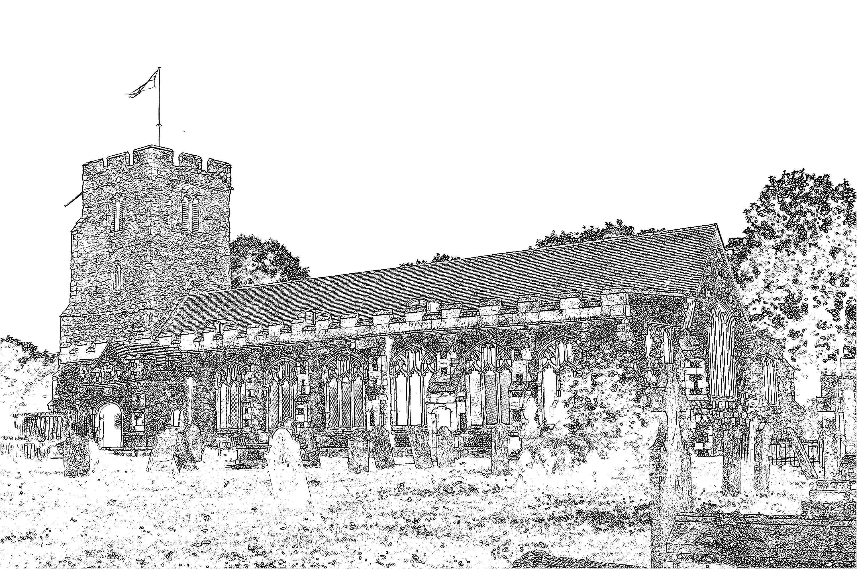
Parish Church of
St Mary the Virgin
Burnham on Crouch

Welcome to our Celebration Today
During the Sung Mass, the Sunday School meets in the Ringing Chamber, they gather during the first hymn. Please ask the Sidespersons for directions. The Walsingham room is also available as a crèche room for young people who need a break during the service. At the end of Mass please stay and join us for coffee and refreshments. The green books have the Order of Service in them, while the hymns are found in the bigger green book. The numbers are as follows:
green book. The numbers are as follows:

Music at the Sung Mass NEH
Process. Advent Prose 501
Offertory The advent of our God 14
Comm. Wake, O wake! 16
Recess. Long ago, prophets knew 10
Mass Setting W

Rotas – February to July 2013
To enable us to get the rotas to you ASAP in the New Year, Jeremy is starting work on them now. If you are on any of the rotas – sidesperson, intercessor, refreshments, reader or counter – please can you let Jeremy have your dates to avoid for February to July 2013 in writing by the end of the 10am Mass on 23rd December. If you would like to join or know more about the rota, please see Jeremy. Some of our rotas only have three couples on at the moment so this means people are having to do duties twice a month. Please give thought as to how you might be able to use your talents to support the work of the Church on a Sunday.

Handmade Christmas Cards
On sale at the back of Church, small £1 each and large £2 each. All profits to Church funds. If you wish to order special cards please speak to Pam or Linda.

Confirmation
The Bishop of Bradwell will be spending Easter in our Parish. At the Easter Vigil he will be administering the Sacrament of Confirmation. To prepare those who would like to be confirmed, confirmation classes will start after Christmas. Please speak to Father Mark for course details and an application form.

Parish Contacts:
Vicar Fr Mark North SSC 01621 782071
frmarknorth@btinternet.com
Churchwardens - David Boyton 01621 781141
Jeremy Cousins 01621 786066

Parish Website: www.stmarysburnham.co.uk

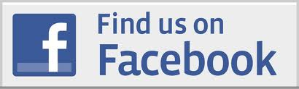 and

