Parish Diary

Mon 9th Feria (5th week in Ordinary Time)
We pray for Fr Peter & his new ministry in Southminster

Tue 10th St Scholastica
We pray for Vocations to the Religious Life

08.30 Morning Prayer
09.00 Mass
15.30 Improvement Board Meeting
(at St Mary’s School)
17.00 Vespers
19.00 Bell ringing practise
19.30 Induction of Rev Peter Begley
(at St Leonard’s)

Wed 11th Our Lady of Lourdes
We pray for the Sick

08.30 Morning Prayer
09.00 CTB United Prayers (at URC)
19.00 Vespers
19.30 Mass

Thur 12th Feria
We pray for our Parish School

08.30 Morning Prayer
09.15 School Mass (St Mary’s School)
12.15 Mass
13.30 Strategy Working Group
(at St Mary’s School)
17.00 Vespers
19.30 Social & Fundraising Committee
(at The Vicarage)

Fri 13th Feria
We pray for John, our Area Bishop

07.30 Morning Prayer
08.00 Mass
09.00 Collective Worship
(at St Mary’s School)
17.00 Vespers

Sat 14th Ss Cyril (Monk) & Methodius (Bishop)
(Co-Patrons of Europe)
We pray for the Church in Europe

10.00 PCC Away Day

Sixth Sunday in Ordinary Time
We pray for our Parish

18.00 First Mass of Sunday

Sun 15th

8.00 Mass
09.00 Morning Prayer
10.00 Sung Mass

Details for next week’s pew sheet to be sent to Father Mark by Wednesday
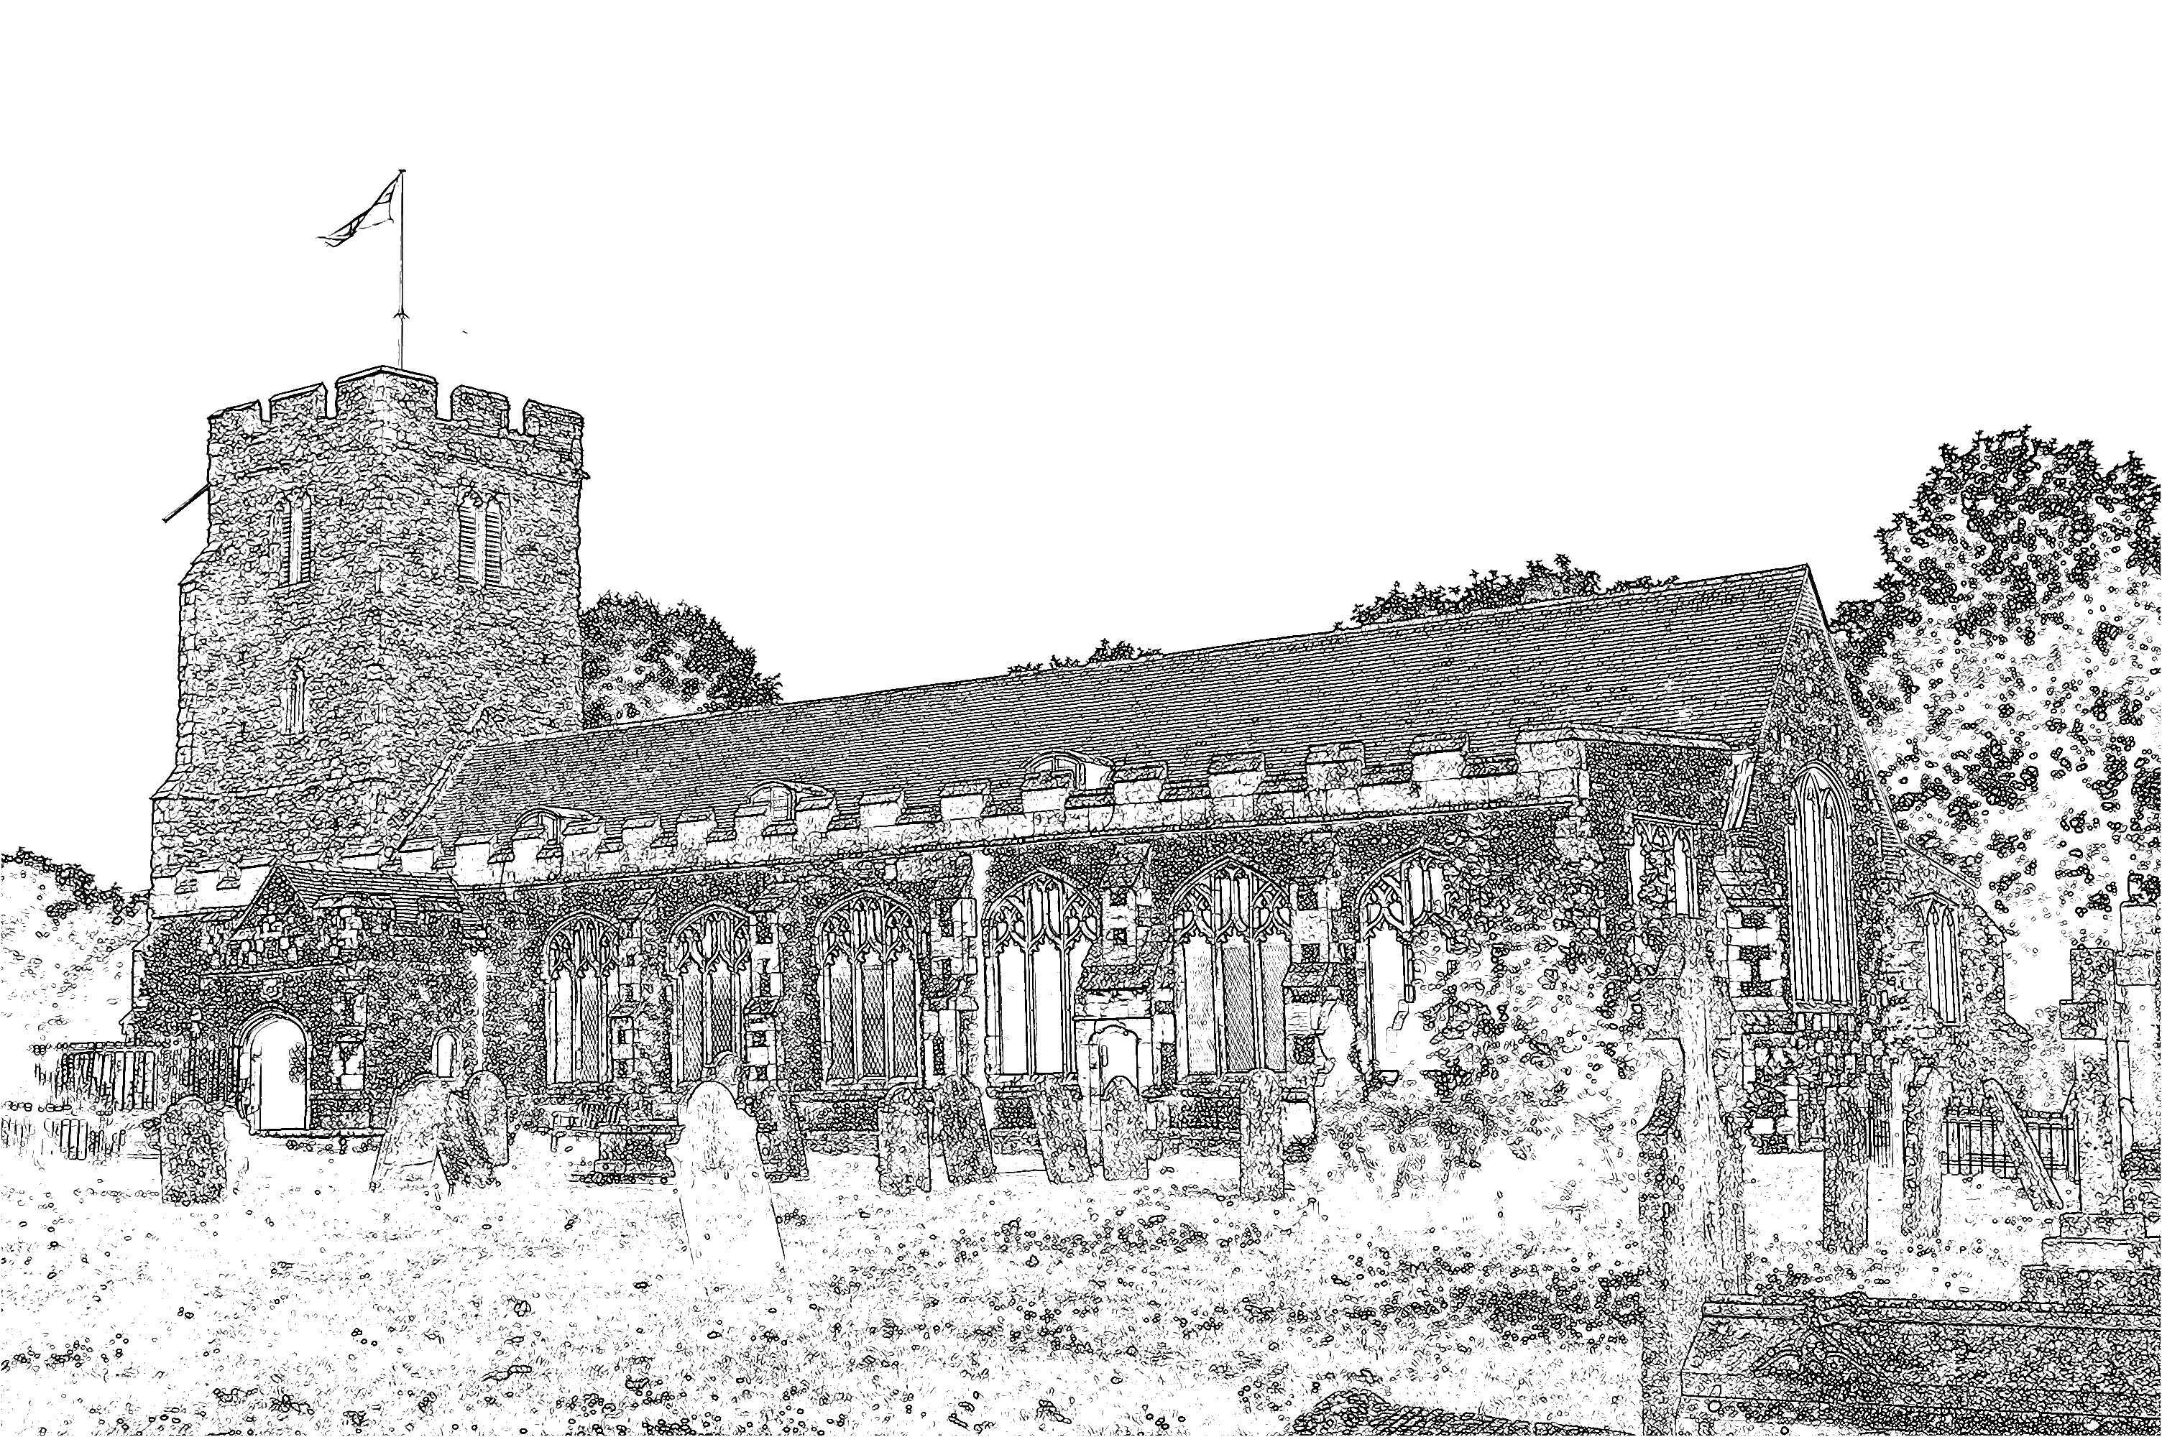
Parish Church of
St Mary the Virgin
Burnham-on-Crouch

Welcome to our Celebration Today
During the Sung Mass, the Sunday School meets in the Ringing Chamber, they gather during the first hymn and return in time for the peace. Please ask the Sidespersons for directions. The Walsingham room is also available as a crèche room for young people who need a break during the service. At the end of Mass please stay and join us for coffee and refreshments. The green books have the Order of Service in them, while the hymns are found in the bigger green book. The numbers are as follows:

Music at the Sung Mass HON
Process. All my hope on God is founded 15
Offertory I heard the voice of Jesus say 231
Comm. Sweet sacrament divine 463
Process. Praise, my soul, the King of heaven! 422
Mass Setting M

Readings for Sunday 15th February:
First Reading: Deuteronomy 5:12-15
Psalm: Psalm 81:1-10
Second Reading: 2 Corinthians 4:5-12
Gospel: Mark 2:23 – 3:6

Christingle Service
Thank you to those who helped support the Christingle Service, we raised £51.81 for the Childrens’ Society.

Prayer
The weekly prayer cycle is available from the table at the back of Church. Please remember to complete the prayer request slips for all those that you know need a prayer. Prayer can be offered for difficult situations, as well as the needs of individuals.

School Mass
Takes place at our Parish school on Thursday at 9.15am. All are welcome.

The Social & Fundraising Committee
Our social and fundraising calendar is in desperate need of new ideas! The Churchwardens have organised a meeting on Thursday at 7.30pm for all those interested in sharing ideas of things and events that we can do together. All are welcome.

Parish Contacts
Vicar: Fr Mark North SSC 01621 782071
frmarknorth@btinternet.com
Churchwarden: Beth Greaves 01621 786296
Tony Young 01621 929309
Parish Website: www.stmarysburnham.co.uk
and

