Parish Diary

Mon 5th Easter Feria
We pray for the Royal British Legion

10.30 Book Sale – until 15.30

Tue 6th Easter Feria
We pray for our Bible Study Group

08.30 Morning Prayer
09.00 Mass
17.00 Vespers
19.00 Bell ringing practise
20.00 Bible Study (at The Vicarage)

Wed 7th Easter Feria
We pray for Ormiston Rivers Academy

08.30 Morning Prayer
09.00 CTB United Prayers (at LWCC)
10.00 Strategy Committee Meeting (at ORA)
10.30 Edward Bear Club
12.30 Full Governing Body Meeting (at ORA)
14.30 Deanery Chapter
(at St Luke’s Centre, Maylandsea)
19.00 Vespers
19.30 Mass

Thur 8th Easter Feria
We pray for Candidates for Confirmation

08.30 Morning Prayer
12.15 Mass
16.30 Curriculum & Standards Committee
Meeting (at St Mary’s School)
19.30 Confirmation (at St Stephen’s, Cold Norton)

Fri 9th Easter Feria
We pray for the work of Christian Aid

07.30 Morning Prayer
08.00 Mass
09.00 Collective Worship (St Mary’s School)
17.00 Vespers

Sat 10th Easter Feria
We pray for Churches Together in Burnham

10.00 Standing Committee (at The Vicarage)

Fourth Sunday of Easter
We pray for our Parish

18.00 First Mass of Sunday

Sun 11th

08.00 Mass
09.00 Morning Prayer
10.00 Sung Mass
17.00 Bereavement Service & Tea

Readings for Sunday 11th May:
First Reading: Acts 2:42-47
Psalm: Psalm 23
Second Reading: 1 Peter 2:19-25
Gospel: John 10:1-10

Details for next week’s pew sheet to be sent to Father Mark by Wednesday
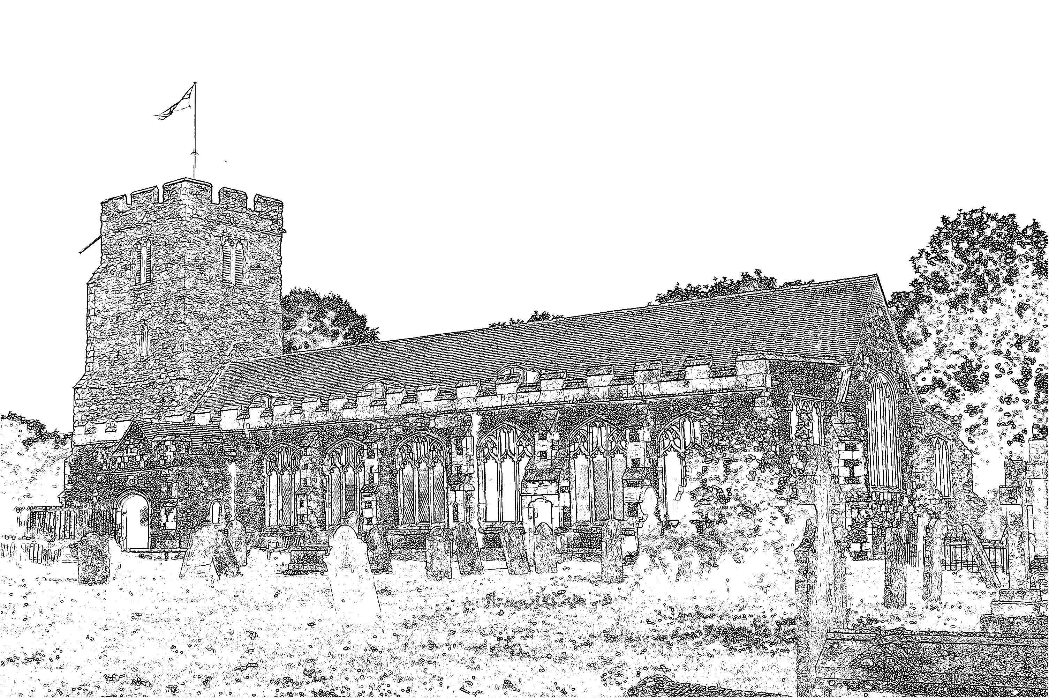
Parish Church of
St Mary the Virgin
Burnham-on-Crouch

Welcome to our Celebration Today
At the Sung Mass, we welcome Alannah Cawson as she receives the Sacrament of Baptism. We extend our welcome to her godparents, family and friends who have come to support her. The Sunday School meets in the Ringing Chamber, they gather during the first hymn and they come down to witness the Baptism. Please ask the Sidespersons for directions. The Walsingham room is also available as a crèche room for young people who need a break during the service. At the end of Mass please stay and join us for coffee and refreshments. The gold books have the Order of Service in them, while the hymns are found in the bigger green book. The numbers are as follows:

Music at the Sung Mass NEH
Process. Christ is the King 345
Offertory At the Lamb’s high feast we sing 104
Comm. Now the green blade riseth 115
Recess. We have a gospel to proclaim 486
Mass Setting F

We also look forward to welcoming Esther Lance as she comes this afternoon to receive the Sacrament of Baptism. Members of the congregation are welcome to join her godparents, family and friends for the service this afternoon.

Big Burnham Book Sale
Is tomorrow from 10.30am to 3.30pm here at St Mary’s. Help needed this afternoon to lay out books and get everything ready for tomorrow.

Christian Aid Collection
Christian Aid week begins next Sunday, 11th May. The list of roads we are covering is on the table at the back of Church with the resources needed for each road. If you are able to cover one of these roads, please enter your name on the list and then take the correct bag.

Please try and complete your delivery and collection of envelopes during the actual Christian Aid week. There are also various activities being arranged during this week, please see posters for details and support where you can.

Children’s Society Box Opening
Many thanks to all Box Holders. The sum raised this year was £503.03, which is again an increase on the previous year. Anyone interested in having a box should contact Maureen Cousins on 01621 783136.

Parish Contacts
Vicar: Fr Mark North SSC 01621 782071
frmarknorth@btinternet.com
Churchwarden: Beth Greaves 01621 786296
Jeremy Cousins 01621 786066
Parish Website: www.stmarysburnham.co.uk
and

