Parish Diary

Mon 4th Lent Feria
We pray for the Royal British Legion

Tue 5th Lent Feria
We pray for our Lent Group

08.30 Morning Prayer
09.00 Mums’ Mass
13.30 Governors’ Course (Wickford)
17.30 Vespers
20.00 Lent Group (at The Vicarage)

Wed 6th Lent Feria
We pray for the Edward Bear Club

08.30 Morning Prayer
09.00 CTB United Prayers (at URC)
10.30 Edward Bear Club
11.15 Funeral Bill Hyam RIP
(at Chelmsford Crematorium)
19.00 Vespers
19.30 Stations of the Cross and Mass

Thur 7th Lent Feria (Com Ss Perpetua &
Felicity Mrr)
We pray for the Persecuted Church

08.30 Morning Prayer
12.15 Mass
17.30 Vespers
19.00 Full Governing Body Meeting
(at St Mary’s School)

Fri 8th Lent Feria (Com St John of God)
We pray for those living the religious life

07.00 Mass
07.30 Morning Prayer
09.00 Collective Worship
(at St Mary’s School)
10.30 Funeral Elsie Hammond RIP
14.20 Ormiston Rivers Academy Year 9
Lesson
17.00 Vespers

Sat 9th Lent Feria
We pray for Churches Together in Burnham

Fourth Sunday of Lent
We pray for our Parish

18.00 Vigil Mass

Sun 10th

08.00 Mass
09.00 Morning Prayer
10.00 Sung Mass
17.00 Vespers and Reflection
17.30 Confirmation Class

Details for next week’s pew sheet to Father Mark by Wednesday

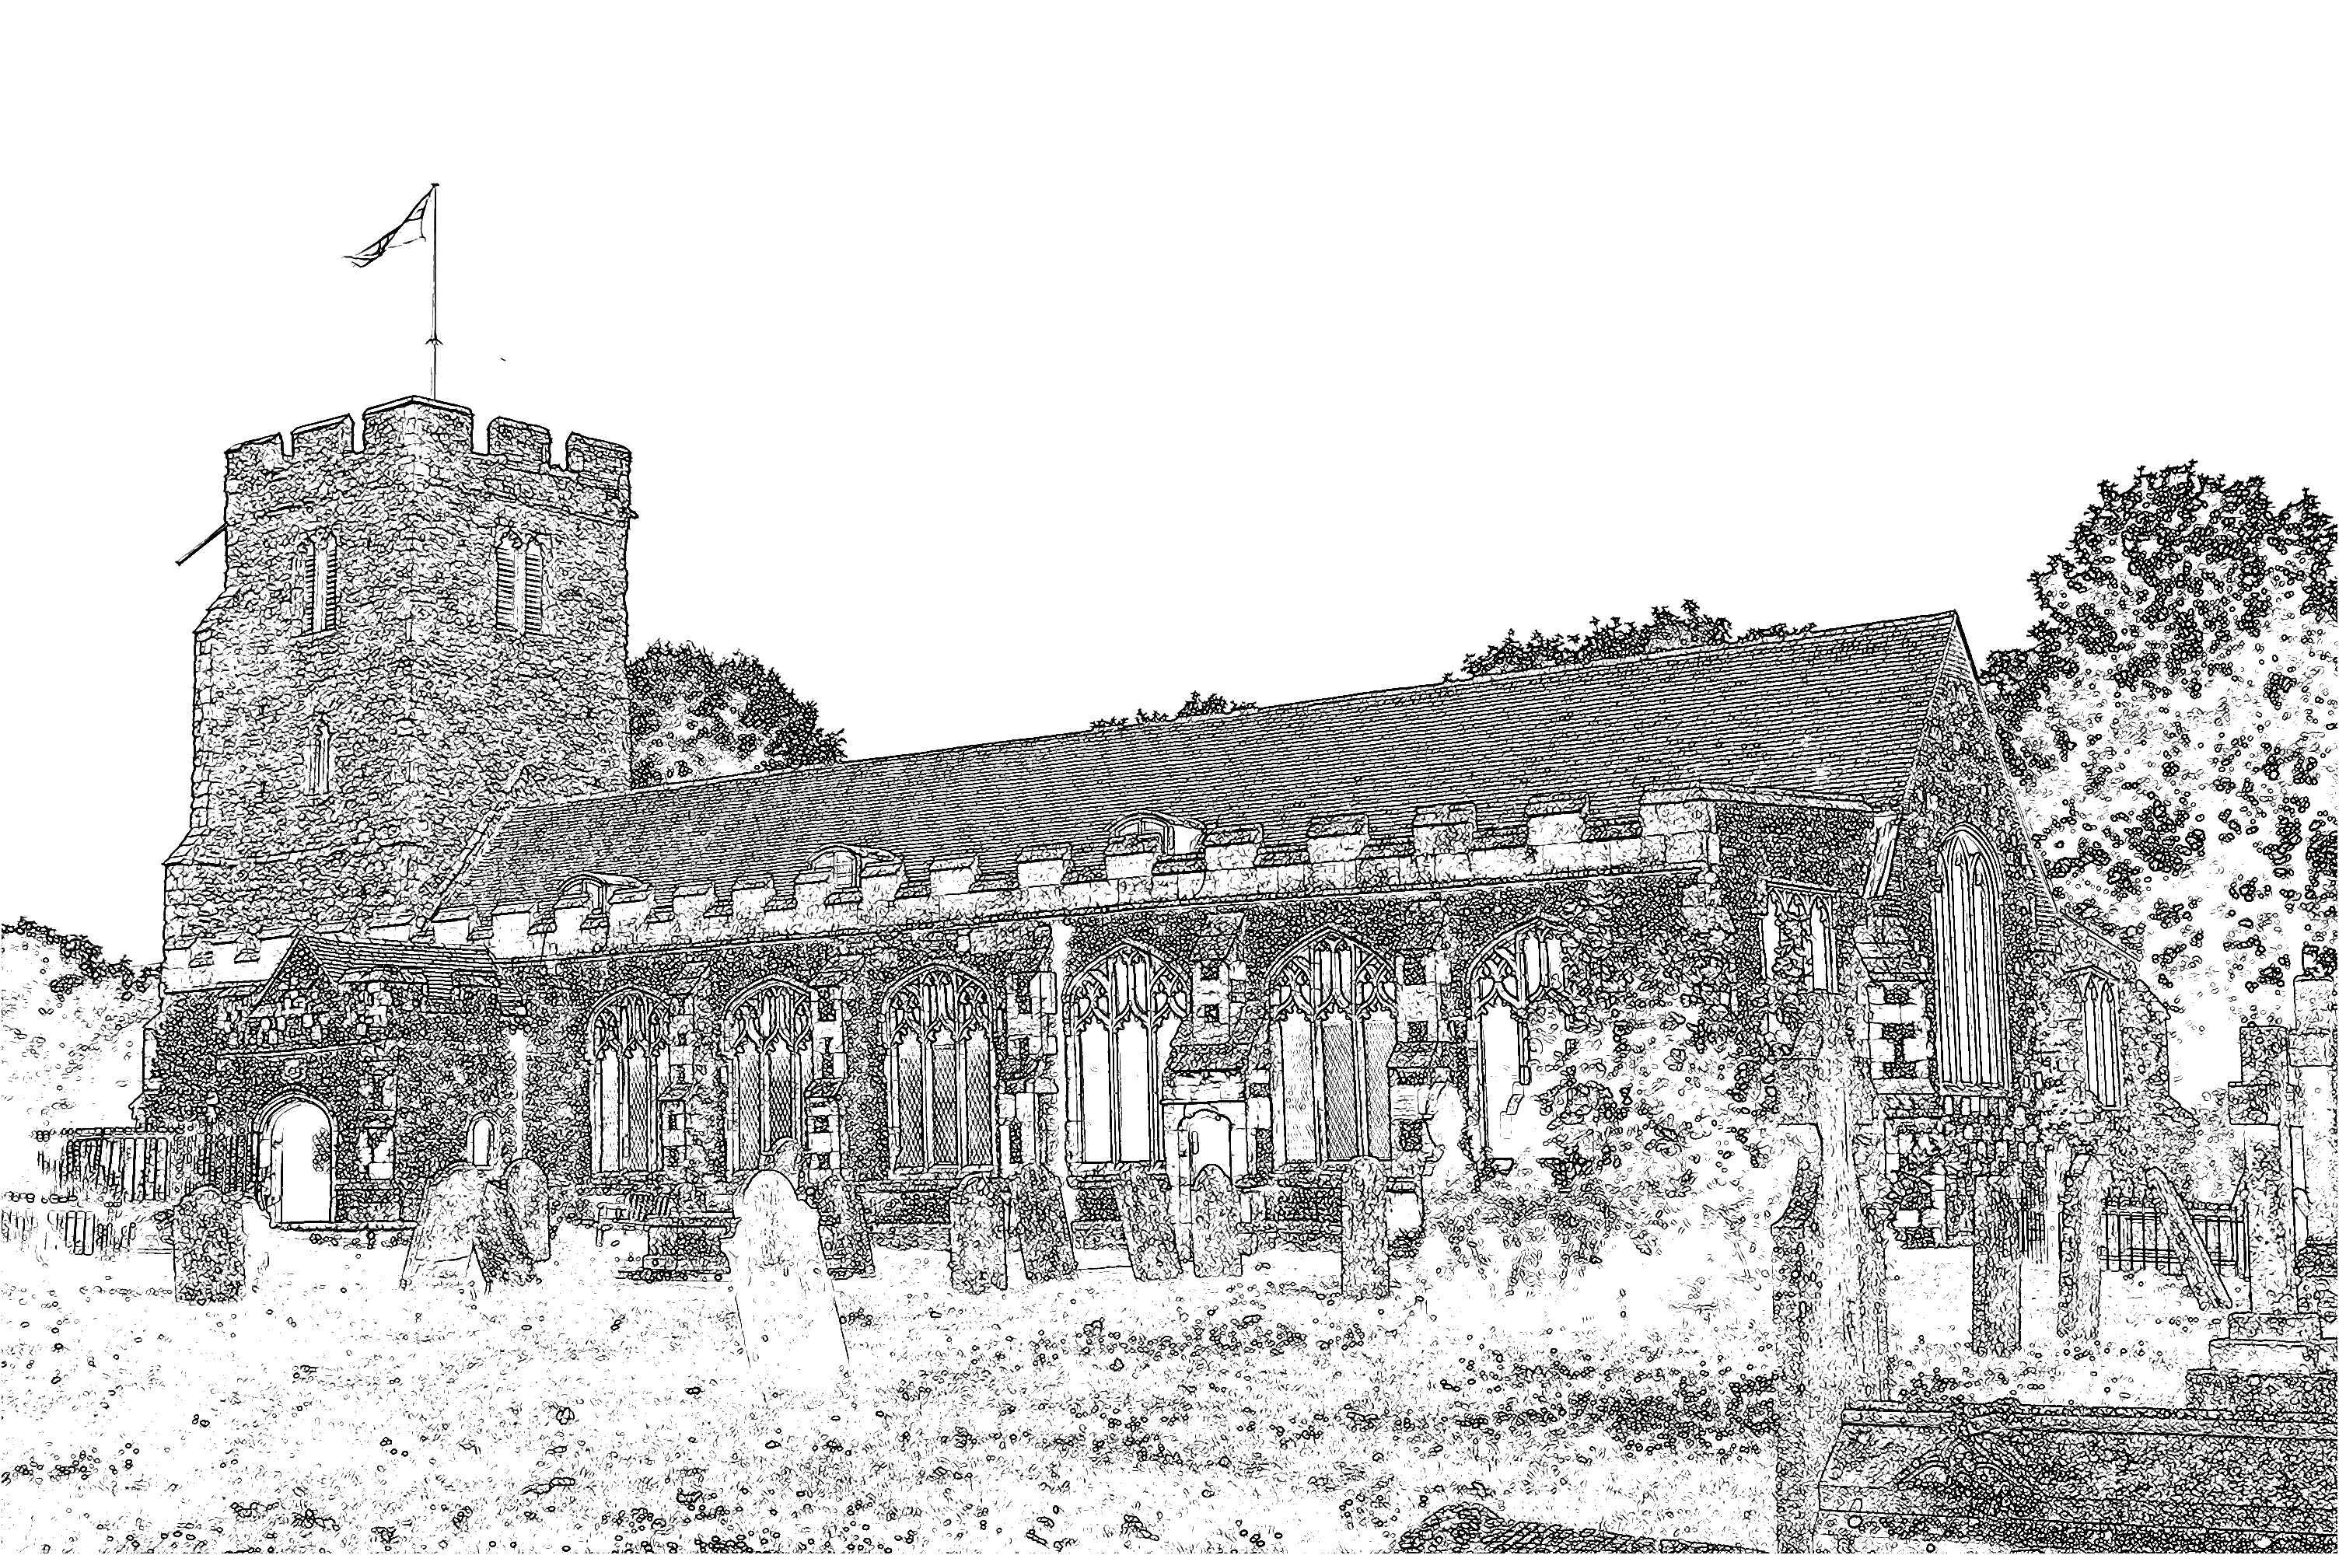
Parish Church of
St Mary the Virgin
Burnham-on-Crouch

Welcome to our Celebration Today
During the Sung Mass, the Sunday School meets in the Ringing Chamber, they gather during the first hymn. Please ask the Sidespersons for directions. The Walsingham room is also available as a crèche room for young people who need a break during the service. At the end of Mass please stay and join us for coffee and refreshments. The green books have the Order of Service in them, while the hymns are found in the bigger green book. The numbers are as follows:

Music at the Sung Mass NEH
Process. Forty days and forty nights 67
Offertory I heard the voice of Jesus say 376
Comm. My faith looks up to thee 72
Recess. Praise to the Holiest 439
Mass Setting W

Readings for Sunday 10th March:
First Reading: 1 Samuel 1.20-28
Psalm: Psalm 127.1-4
Second Reading: Colossians 3.12-17
Gospel: John 19.25b-27

Easter Rotas
The lists of readers and helpers required for our keeping of Easter are now available at the back of Church. Please volunteer where you can!

Easter Lilies
As is traditional, we will be decorating the Church with lilies on Easter Sunday. If you would like to have a lily in remembrance of a loved one, please complete one of the slips at the back of the Church. Each lily costs £5 and the money and the slip should be returned to Jeremy by 11.30am on Sunday 17th March, so that the order can be submitted to the florist. As with last year can we ask everyone wishing to order lilies to complete a slip. Any queries please see Jeremy.

Electoral Roll
This year the Electoral Roll needs to be completely revised, which means that everybody currently on the roll will have to complete a new application form and submit to the Electoral Roll Officer. The roll is open for revision until Sunday 17th March. Application forms are available at the back of the Church.

Parish Contacts:
Vicar Fr Mark North SSC 01621 782071
frmarknorth@btinternet.com
Churchwardens - David Boyton 01621 781141
Jeremy Cousins 01621 786066

Parish Website: www.stmarysburnham.co.uk

and

