Parish Diary

Mon 3rd Feria (27th week in Ordinary Time)
We offer Harvest Thanksgivings

Tue 4th St Francis of Assisi
We pray for the Franciscans

08.30 Morning Prayer
09.00 Mass
10.00 St Mary’s School Harvest Service
14.15 Churches Together Committee Meeting
(at URC)
17.00 Vespers
19.00 Bell ringing practise
20.00 Bible Study Group (at The Vicarage)

Wed 5th Feria
We pray for our Bible Study Group

09.00 Clergy Leadership Programme
(at the Diocesan Office)
19.00 Vespers
19.30 Mass

Thur 6th Feria
We pray for our School Governors

08.30 Morning Prayer
12.15 Mass
16.30 Full Governing Body Meeting
(at St Mary’s School)
18.30 Governor Development Session
(at St Mary’s School)

Fri 7th Our Lady of the Rosary
We pray for the Needy & the Hungry

07.30 Morning Prayer
08.00 Mass
09.00 Collective Worship (at St Mary’s School)
17.00 Vespers

Sat 8th Feria
We pray for Ethan Bonner to be Baptised

09.00 Morning Prayer

20th Sunday after Trinity
We pray for our Parish

18.00 First Mass of Sunday

Sun 9th

08.00 Mass
09.00 Morning Prayer
10.00 Sung Mass and Holy Baptism
Ethan Bonner

Details for the following week’s pew sheet to be sent to Father Mark by Thursday
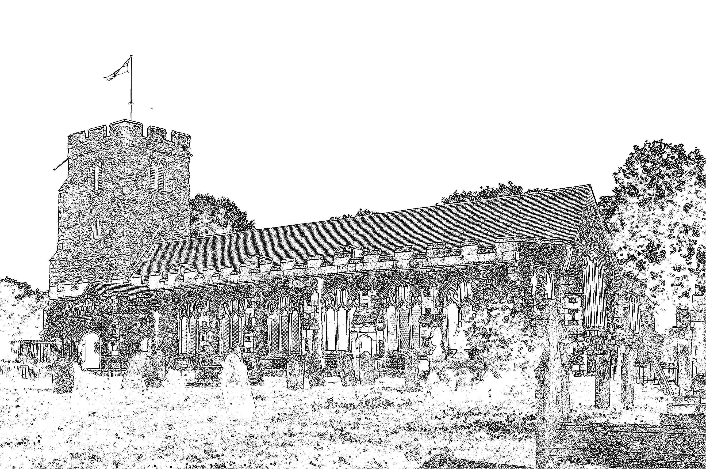
Parish Church of
St Mary the Virgin
Burnham-on-Crouch

Welcome to our Celebration Today
The Walsingham room is available as a crèche room for young people who need a break during the service. The Sidespersons have bags of toys for younger visitors to use during the service. At the end of Mass, please stay and join us for coffee and refreshments. The green books have the Order of Service in them, while the hymns are found in the bigger green book. The numbers are as follows:

Music at the Sung Mass NEH
Process. Come, ye thankful people, come 259
Offertory All creatures of our God and King 263
Comm. For the beauty of the earth 285
Process. We plough the fields, and scatter 262
Mass Setting M

Readings for Sunday 9th October:
First Reading: 2 Kings 5:1-3. 7-15c
Psalm: Psalm 111
Second Reading: 2 Timothy 2:8-15
Gospel: Luke 17:11-19

Harvest Thanksgiving
We keep our harvest thanksgiving today. We thank local organisations that have decorated the window ledges in Church. Our Harvest this year will go to support the Mustard Seed Appeal, details below.

Mustard Seed Appeal
The Archbishop of Canterbury has spoken out about creating a more just financial system to help millions of people who are struggling with debt. Following successful pilot work in two regions, the plan is for a national roll out to tackle the issue head-on. The Archbishop of Canterbury’s Mustard Seed Appeal is raising vital funds to make this happen. Churches throughout the country are organising fundraising events for the Mustard Seed Appeal as we work together to build a just financial system. If you would like to contribute, please place your donation in the separate plate at the back of Church.

Memorial Garden
Our landscape gardener will begin the hard landscaping this coming Wednesday. The work should take about six weeks, but there should be no disruption to services or our access to the Church building. Some of the spoil will be used to fill the hollows on the Church Green, this will be graded and seeded as the work draws to a conclusion.

Baptism
Next Sunday we look forward to welcoming Ethan Bonner, his parents and Godparents, as they prepare for Ethan’s Baptism.

Parish Contacts
Vicar: Fr Mark North SSC 01621 782071
frmarknorth@btinternet.com
Churchwarden: Beth Greaves 01621 786296
Tony Young 01621 929309
Parish Website: www.stmarysburnham.co.uk
and

