Parish Diary

Mon 23rd 8th Week of Ordinary Time
We pray for the Society of the Holy Cross

09.00 Mass (at St Mary’s School)
12.00 SSC Chapter (Great Barfield)

Tue 24th Feria
We pray for our Churchwardens

08.30 Morning Prayer
09.00 Mass
17.00 Vespers
19.00 Bell ringing practise
19.30 Churchwardens’ Meeting
(St Leonard’s, Southminster)

Wed 25th St Bede the Venerable (Priest & Dr)
We pray for Theologians

08.30 Morning Prayer

Thur 26th St Philip Neri (Priest)
We pray for our Parish Clergy

12.15 Mass
17.00 Vespers

Fri 27th St Augustine of Canterbury (Bishop)
We pray for Justin, Archbishop of Canterbury

07.30 Morning Prayer
08.00 Mass
17.00 Vespers

Sat 28th Our Lady on Saturday
We pray for Pilgrims at Walsingham

09.00 Morning Prayer
10.00 – 12.00 Coffee Morning & Plant Sale
(10 Fernlea Road)

Corpus Christi
We pray for our Parish

18.00 First Mass of Sunday

Sun 29th

08.00 Mass
09.00 Morning Prayer
10.00 Sung Mass
15.00 – 16.00 Bishop Stephen’s Missionary
Journey (Mangapps Railway Museum)

Readings for Sunday 29th May:
First Reading: Genesis 14.18-20
Psalm: Psalm 116.10-17
Second Reading: 1 Corinthians 11.23-26
Gospel: John 6.51-58

Details for the following week’s pew sheet to be sent to Father Mark by Wednesday
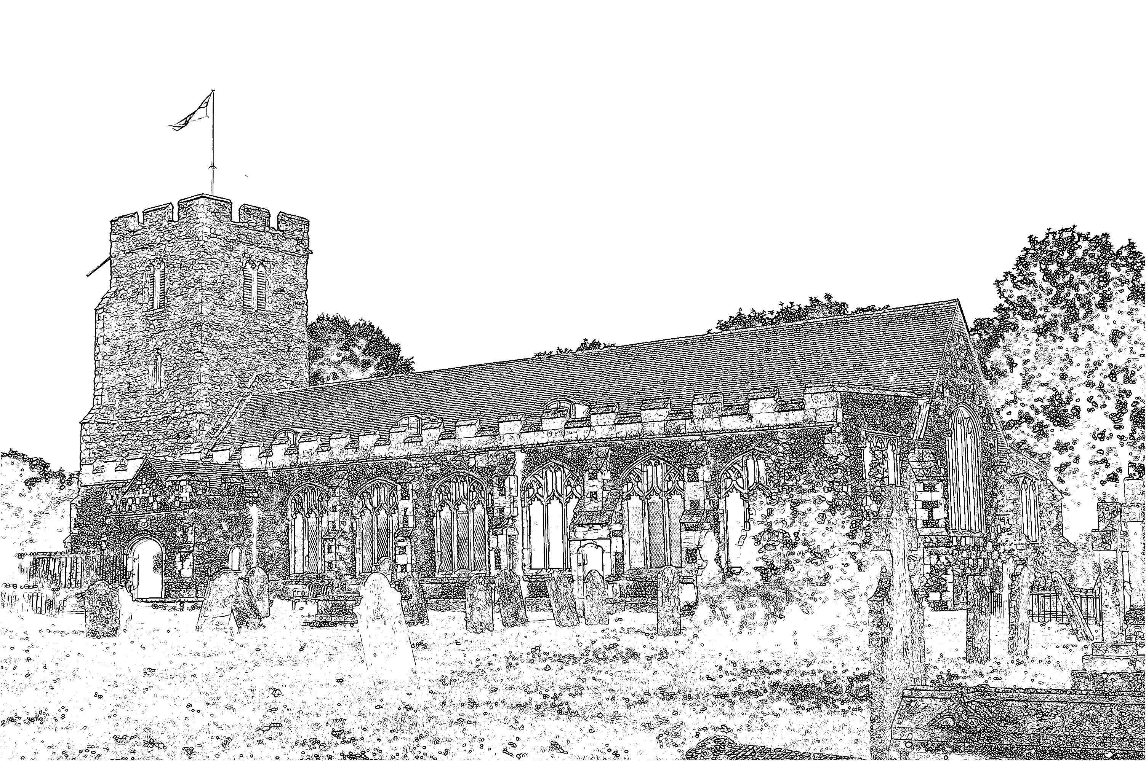
Parish Church of
St Mary the Virgin
Burnham-on-Crouch

Welcome to our Celebration Today
The Walsingham room is available as a crèche room for young people who need a break during the service. The Sidespersons have bags of toys for younger visitors to use during the service. At the end of Mass please stay and join us for coffee and refreshments. The green books have the Order of Service in them, while the hymns are found in the bigger green book. The numbers are as follows:

Music at the Sung Mass NEH
Process. Holy, Holy, Holy! Lord God Almighty 146
Offertory Bright the vision that delighted 343
Comm. Bread of heaven, on thee we feed 276
Process. Thou whose almighty word 466
Mass Setting F

Service of Remembrance & Thanksgiving
Takes place this afternoon at 5pm. During this service, the recently departed will be prayed for and there will be an opportunity for a candle to be lit as a sign of our prayers for our loved ones.

Corpus Christi
Next Sunday we keep the Feast of Corpus Christi, the service will conclude with a Procession of the Blessed Sacrament. Incense will be used at this service.

Barbecue
Thank you to those who supported the Pentecost party. It was a most enjoyable afternoon when we got a chance to meet fellow Christians from across the town.

Christian Aid
Christian Aid Week concludes today. Please hand your collected envelopes to John Green. Thank you to those who supported our Coffee Morning on Friday.

Coffee Morning & Plant Sale
Linda and John Green will be holding a Coffee Morning and Plant Sale next Saturday from 10am until 12 noon. There will be busy lizzies, petunias, geraniums and a limited number of bedding begonias, plus an assortment of perennials. If you are unable to attend but would like plants, then please see John. Even if you are not a gardener, please come along for coffee and cake. All funds to be shared between their grand-daughter's World Challenge and St Mary's Church.

Bishop Stephen’s Missionary Journey
Through the Dengie on Sunday 29th May, finishing at Mangapps Railway Museum. Please come along from 3pm to meet Bishop Stephen.

Parish Contacts
Vicar: Fr Mark North SSC 01621 782071
frmarknorth@btinternet.com
Churchwarden: Beth Greaves 01621 786296
Tony Young 01621 929309
Parish Website: www.stmarysburnham.co.uk
and

