Parish Diary

Mon 20th Feria (7th week of Ordinary Time)
We pray for our Parish Clergy

Tue 21st Feria
We pray for Members of the Parochial Church Council

08.30 Morning Prayer
09.00 Mums’ Mass
17.30 Vespers
20.00 PCC Meeting

Wed 22nd Feria
We pray for our Churchwardens

08.30 Morning Prayer
09.00 CTB United Prayers
19.00 Vespers
19.30 Mass

Thur 23rd Feria
We pray for our Organist & Choir

08.30 Morning Prayer
12.15 Mass
17.30 Vespers
19.00 Archdeacon’s Visitation
(All Saints, Maldon)

Fri 24th Feria
We pray for Joe Parkes & Katy Maidment

07.00 Mass
07.30 Morning Prayer
09.00 Collective Worship (at St Mary’s School)
17.00 Vespers
17.30 Wedding Rehearsal

Sat 25th St Bede the Venerable (Priest)
We pray for Biblical Scholars

10.00 Plant Sale & Coffee Morning
(John & Linda’s house)
13.30 Wedding
Joseph Parkes & Katy Maidment

The Most Holy trinity
We pray for our Parish

18.00 Vigil Mass

Sun 26th

08.00 Mass
09.00 Morning Prayer
10.00 Sung Mass and Holy Baptism
Jessica Rippin

Readings for Sunday 26th May:
First Reading: Proverbs 8:1-4. 22-31
Psalm: Psalm 8
Second Reading: Romans 5:1-5
Gospel: John 16:12-15

Details for next week’s pew sheet to Father Mark by Wednesday

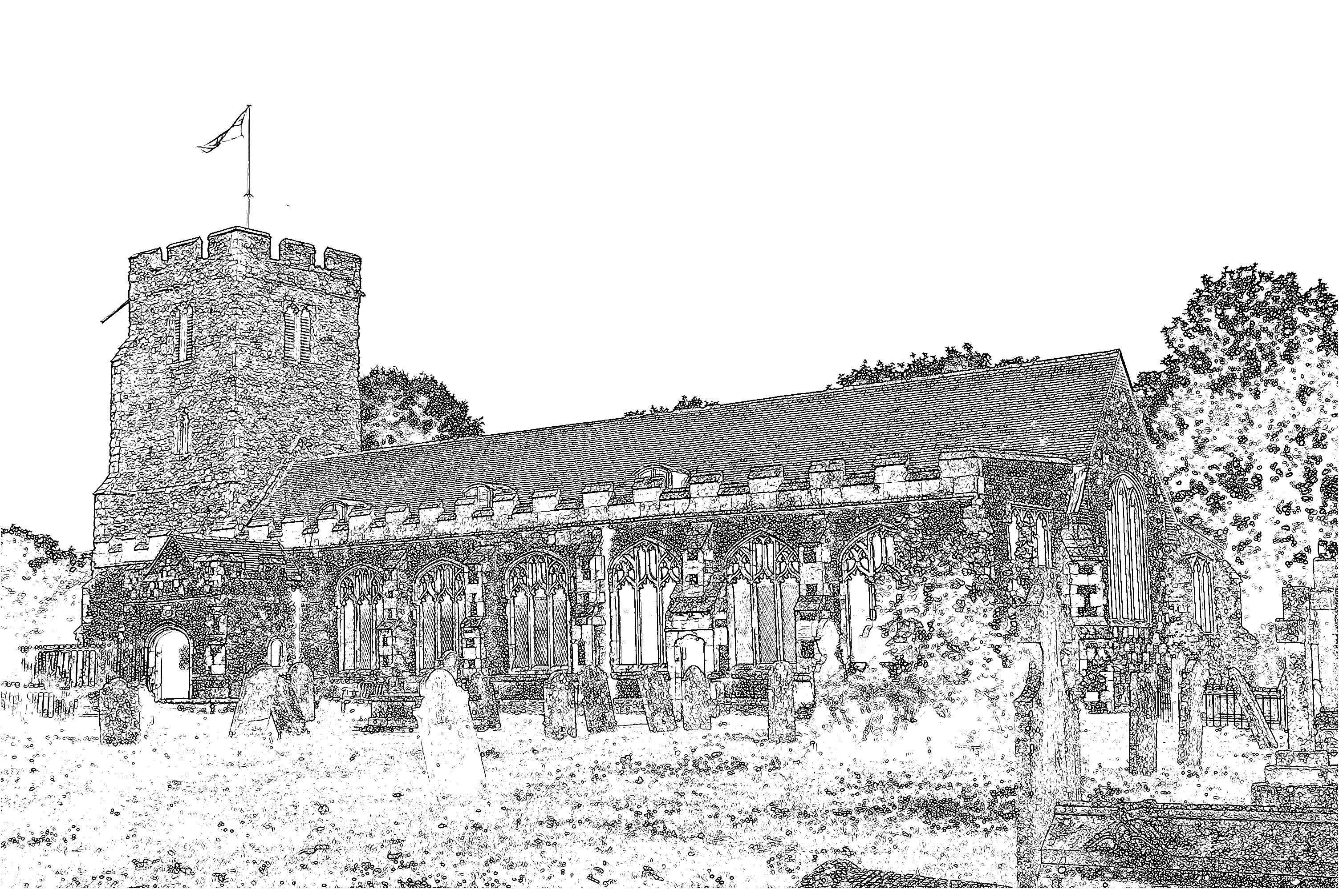
Parish Church of
St Mary the Virgin
Burnham-on-Crouch

Welcome to our Celebration Today
During the Sung Mass, the Sunday School meets in the Ringing Chamber, they gather during the first hymn. Please ask the Sidespersons for directions. The Walsingham room is also available as a crèche room for young people who need a break during the service. At the end of Mass please stay and join us for coffee and refreshments. The green books have the Order of Service in them, while the hymns are found in the bigger green book. The numbers are as follows:

Music at the Sung Mass HON
Process. O thou who camest from above 392
Offertory Come down, O Love divine 90
Comm. Come, Holy Ghost 92
Recess. Gracious Spirit, Holy Ghost 184
Mass Setting F

We welcome Mia, Constance, Sarah-Jane, Michael, Gabriel, Abigail and Caleb who are coming for Baptism today and assure them of our prayers and best wishes as they enter into the Christian faith.

Christian Aid
Thank you for those who took part in the house to house collections. Please bring your envelopes and bags back to Church for counting.

Plant Sale & Coffee Morning
This Saturday John & Linda Green are holding the Plant Sale & Coffee Morning at 10 Fernlea Road, Burnham, from 10am – 12.30pm. All the usual plants will be available, petunias, busy lizzies and geraniums, plus an assortment of perennial plants. For the non-gardeners there will be the usual tea, coffee and cakes. Everyone welcome but if you are unable to attend but require plants please speak to John this week or phone 783114.

Teddy Bear Parachute
On Saturday 8th June we will be repeating our very successful Teddy Bear Parachute Day. As well as watching our intrepid teddies jump off the tower we will have a few stalls and be providing an opportunity for families to take part in a Teddy Bears Picnic on the Church green. There is a sheet at the back of the Church for volunteering to help and provide refreshments. Any queries please speak to Jeremy.

Holy Baptism
Next Sunday we look forward to welcoming Jessica Rippin as she receives the Sacrament of Baptism at the Sung Mass.

Parish Contacts:
Vicar Fr Mark North SSC 01621 782071
frmarknorth@btinternet.com
Churchwardens – Beth Greaves 01621 786296
Jeremy Cousins 01621 786066
Parish Website: www.stmarysburnham.co.uk
and

