Parish Diary

Mon 28th Easter Monday
We give thanks for the Resurrection

Tue 29th Easter Tuesday
We pray for Justin, our Archbishop

08.30 Morning Prayer
09.00 Mass
17.00 Vespers
19.00 Bell ringing practise
20.00 PCC Meeting

Wed 30th Easter Wednesday
We pray for Pope Francis I

08.30 Morning Prayer
19.00 Vespers
19.30 Mass

Thur 31st Easter Thursday
We pray for Bartholomew, Ecumenical Patriarch

08.30 Morning Prayer
12.15 Mass
14.00 Memorial Service Alan Henry RIP
17.00 Vespers

APRIL

Fri 1st Easter Friday
We pray for Christian Unity

07.30 Morning Prayer
08.00 Mass
14.15 Rehearsal for Renewal of Vows
17.00 Vespers

Sat 2nd Easter Saturday
We pray for Matthew & Louise Pudney

09.00 Morning Prayer
15.30 Renewal of Vows
Matthew & Louise Pudney

Second Sunday of Easter
We pray for our Parish

18.00 First Mass of Sunday

Sun 3rd

08.00 Mass
09.00 Morning Prayer
10.00 Sung Mass

Readings for Sunday 3rd April:
First Reading: Acts 5:27-32
Psalm: Psalm 150
Second Reading: Revelation 1:4-8
Gospel: John 20:19-31

Details for the next two weeks’ pew sheets to be sent to Father Mark by Wednesday
Parish Notices

Please join us for coffee and refreshments after the Service.

Music at the Sung Mass Booklet

Thank You
Fr Mark and the Churchwardens would like to express their thanks to everybody who worked so hard to make Holy Week and our celebration of Easter so successful. So many people volunteered their time and talents to clean and make things ready, and as they played important parts in our various liturgies. It is impossible to single out any one person or group or to speak to everyone, so please accept our grateful thanks for all your help and support.

Children Society Box Holders
Please bring your box to Church as soon as possible for the yearly count.

Big Burnham Book Sale
Our sixth book sale will take place on Bank Holiday Monday 2nd May from 10am to 3.30pm here at St Mary’s Church. If you have any books, please bring them to Church from next Sunday. Once again we will require plenty of helpers to set up on the Sunday afternoon, and to return unsold books to storage after the sale has finished. If you can help, please let Beth Greaves know. This is one of our biggest fundraising events, so please give us your support.

Annual Parish Church Meeting
Takes place on Sunday 17th April at 11.30am. During this meeting, Churchwardens and members of the Parochial Church Council will be elected, we will also receive reports about the activities of our Parish during 2015. Nomination forms for Churchwarden and members of the PCC are available in Church.

The Electoral Roll
In preparation for the APCM, the Electoral Roll will need to be revised. If you would like to have your name added to the Roll or you need to update details, please speak to Linda Cleverley, the Electoral Roll Officer.

Walsingham Pilgrimage
Has been booked for the weekend 16th and 17th July 2016. If you are interested in joining the group, please add your name to the list at the back of Church.

Parish Information

Contacts
Vicar
Fr Mark North SSC 01621 782071
frmarknorth@btinternet.com
Churchwardens
Beth Greaves 01621 786296
Tony Young 01621 929309

Pilgrim Course
An introduction to Christianity, we will be running this course in the Autumn. If you are interested in finding out more about the Christian faith, or would like to deepen your knowledge of Christianity, this is the course for you! Please let Fr Mark know of your interest and he will share dates and details later on in the year.

Vigil Mass
This takes place at 6pm on a Saturday evening and is provided for those who find Sunday mornings a challenge, as they try and juggle the demands of Church and family commitments. This service includes all the elements of a Sunday morning, but takes place on a Saturday!

Bell Ringers
The bells of St Mary’s are rung to call people to worship and to celebrate the important events in the life of the community and individuals. We have a peal of six bells but are a bit short of ringers! If you would like to help ensure these bells continue to ring out and learn how to ring, our ringers would love to welcome you. They meet to practice on Tuesday evenings and ring on Sunday mornings. Please contact the Tower Captain, Wendy Hooper on 01621 784166, if you are interested.

Future Events
St Mary’s has a busy programme of social and fundraising events.

The next event after the Book Sale will be the Churches Together Pentecost Barbeque on 15th May at 3pm. This will be followed by a Coffee Morning & Plant Sale on Saturday 28th May at John and Linda Green’s house from 10am. Further details of these events will be found on our Parish website with updates via our social media feeds:

www.stmarysburnham.co.uk

and

Parish Church of
St Mary the Virgin
Burnham-on-Crouch
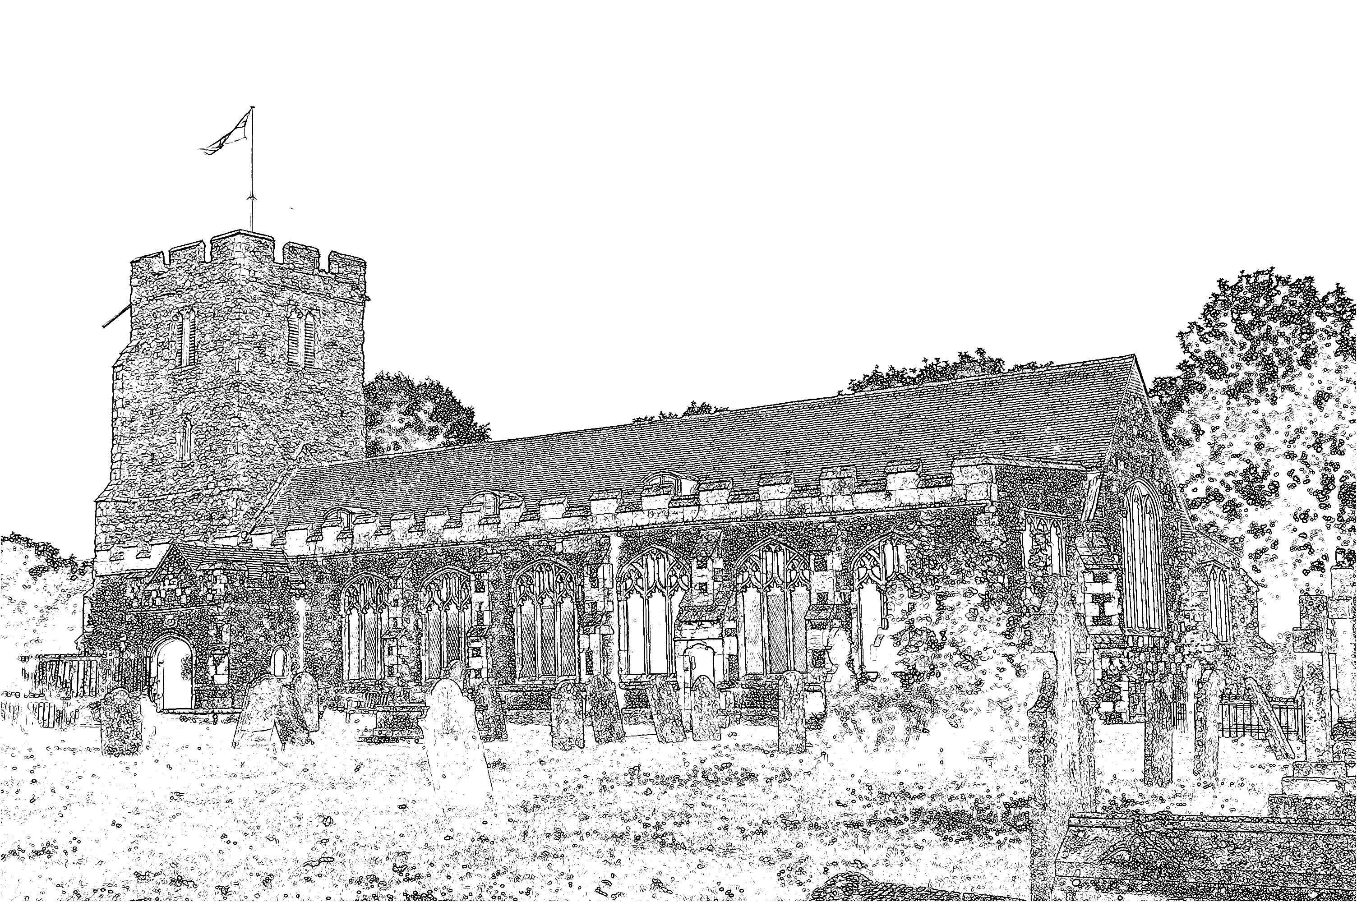

Easter Day
Sunday 27th March 2016

Welcome to St Mary’s Church as we gather to celebrate the resurrection of Our Lord Jesus Christ. For the forty days of Lent we have been preparing ourselves through fasting and works of penance to keep the Easter feast and then in this last week, in Holy Week, we have shared in the great mystery of Christ’s passion through the liturgies of Maundy Thursday and Good Friday. Yesterday evening we lit the paschal candle from the new fire and placed the candle in its place of honour where it remains as a sign of the presence of the Risen Lord in our midst.

We also blessed the water in the font, as the paschal candle was dipped into the water three times. This is a sign of Christ blessing the waters and making them ready for Baptism. During our service this morning we will all have an opportunity to renew our Baptismal promises and then be sprinkled with water from the font as a reminder of our Baptism.

The Walsingham Room has a range of toys and activities for younger people. Please feel free to use this space as you require during the service. The sidespersons can direct you to the Walsingham Room and will encourage you to join us for the renewal of the Baptismal vows.

During the final hymn we shall process outside the Church for the Blessing of the Easter Garden before the children enjoy their egg hunt and the adults their coffee. Please do stay and join us.

Fr Mark

